**Lab Assignment 4**

Vinutha Nuchimaniyanda

Implementing Rest, Soap Service & Soap Web service with Local Database

Extending the Restaurant Mobile Web App, a new button called Web Services has been added to the Main Menu which consists Rest web service, Soap web service and Soap web service with Local database. Below are the screen shots using the Android app with Web View.

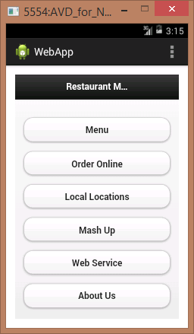

Rest Web Service: I have added description for the menu items in the switch statement in Visual studio and I’m calling that service in the JavaScript click function. So, when an item is clicked, the click function calls the service and the selected item is sent as a parameter to the web service which then returns the description of the item.

|  |  |
| --- | --- |
|  |  |
| Fig 1 | Fig 2 |

The above Fig 1 & Fig 2 of the menu items with different selections displaying different descriptions

Soap Web Service

I’ve again used java script click function that calls the soap webservice to display the addresses of the Restaurant.

|  |  |
| --- | --- |
|  |  |
| Fig 1 | Fig 2 |

The above Fig 1 displays the screenshot before the click is intialized and Fig 2 displays the screenshot after the click is initialized.

Soap web services with the local database

A table called Reviews is created in SQL server database to store the user reviews. A Soap based web service is developed using visual studio to manage user reviews. The web service has three different service methods where Reviews can added, retrieved and removed. These service methods are consumed by Restaurant Mobile Web Application using Soapclient.js .

Below are the screenshots

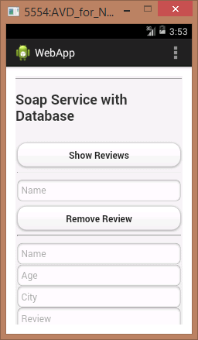

Show Reviews click fuction is triggered in the below screenshot.



Adding a new review.

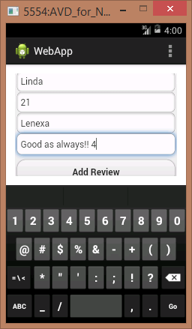

Below is the Screenshot after the record is added.

